Identifying Students’ Summary High School Statistics for Reporting
University Reporting and Research
Revised 8/18/2008
The Office of University Reporting and Research (URR) has developed a process for identifying the summary high school statistics of Indiana University applicants and undergraduates for reporting purposes. These descriptive statistics are from students’ latest high school of attendance, and they include the geographic location of high schools, as well as students’ class rank percentile, grade point average (GPA), and high school graduation date. URR provides these data on a student unit record basis to the Indiana Commission on Higher Education (ICHE), as well as summary descriptive statistics on the undergraduate population to external organizations such as U.S. News and World Report and the U.S. Department of Education.
The sources for these high school data include the external education tables and the academic history table in the IU Student Information System (IU SIS). The IU Offices of Admissions and the Registrar maintain the data in these tables in the IU SIS. The URR process will first be used for official reports beginning in August 2008. Until then, the data can be made available to IU institutional researchers and the IU Offices of Admissions and the Registrar by request.
The goals, logic, and background of the process are described below. This process was first presented to the IU Admissions Council in April 2007, and it reflects both their agreement on the goals and logic, as well as their requests for modifications. Please send any concerns or requests to Greg Tittelbaugh and Todd Schmitz in University Reporting and Research.
Goals
- Identify students’ latest high school of attendance.
- Identify students’ most recent rank percentile and GPA from official sources (school or IU legacy system). These values are not reported for students with GED, generic high school, or home school records.
- Report only valid converted GPA data from the SIS converted GPA field. Valid GPAs correspond with the values in the PeopleSoft GPA conversion table (PS_GPA_RULES_TBL).
- Provide audit reports to the IU Offices of Admissions to identify possible errors and omissions in students’ high school external education records, with the goal of improving the accuracy and completeness of reporting.
- Audits include the following:
  - A student’s class size exceeds the average for that high school by 75 or more students.
  - Cases where a student has only a class rank or class size, but not both, or where the rank exceeds the size.
  - Cases where an IU campus is omitting students’ GPA or rank percentile information when entering external education records, compared with other campuses’ data for students from the same high schools.
  - A student’s GPA falls outside the acceptable ranges, as reflected in the PeopleSoft GPA conversion table (PS_GPA_RULES_TBL).
Logic for selecting high school data for applicants and IU undergraduates
- Select the latest high school records. (Note: if a student has a record in one of these steps, the student will be excluded from the subsequent selection steps in section 1.)
  - Select GED records
  - Select 12th grade high school records with the latest date of attendance and/or receipt at IU.
  - Select 12th grade high school records received from a high school (rather than self-reported by the student), excluding cases where the high school code in IU SIS is a generic high school code.
  - Select 12th grade high school records from the IU legacy mainframe, excluding cases where the high school code in IU SIS is a generic high school code.
  - Select 12th grade high school records where the high school code in IU SIS is a generic high school code.
  - Select the highest grade-level (e.g. 11th grade) high school records with the latest date of attendance and/or receipt at IU.
  - Select the highest grade-level (e.g. 11th grade) records received from a high school (rather than self-reported by the student), excluding cases where the high school code in IU SIS is a generic high school code.
  - Select the highest grade-level (e.g. 11th grade) records from the IU legacy mainframe, excluding cases where the high school code in IU SIS is a generic high school code.
  - Select the highest grade-level (e.g. 11th grade) records where the high school code in IU SIS is a generic high school code.
  - Select records from the IU SIS Academic History table, which only includes the name and location of a student’s high school(s).
- If more than one record per student was selected in section 1, select the most data-rich record for each student. (Note: if a student has a record in one of these steps, the student will be excluded from the subsequent selection steps in section 2.)
  - Select records where a student has a GPA, rank, and class size.
  - Select records where a student has either a GPA, or a rank and class size.
  - Otherwise, select the highest combination of high school code (external organization code) and IU SIS data number (indicating the latest row entered in IU SIS for that student and high school).
- Calculate the class rank percentile from the class rank and size, using this formula:
  - 100 * (1-(class rank / class size))
  - This process excludes GED, generic high school, and home school records.
Columns available with students’ last high school data:
Column Tech. Name | Column Display Name | Column Description
EXT_ORG_ID | High School Org ID | Last high school attended.
STU_HS_ORG_ATP_CEEB_CD | High School CEEB code | College Board School Code for Last High School Attended.
STU_HS_NM | High School Name | Last high school attended.
STU_HS_GRAD_DT | High School Grad Date | Last high school attended.
STU_HS_CLS_RNK_NBR | High School Class Rank | HS overall figure provided by high school for last high school attended.
STU_HS_CLS_SZ_NBR | High School Class Size | HS overall figure provided by high school for last high school attended.
STU_HS_PCTL_NBR | High School Rank Percentile | HS overall figure calculated from the class rank and size provided by high school for last high school attended.
STU_HS_SUM_CNVRT_GPA_NBR | High School Cum GPA Cnvrted to 4-pt Scale | Conversion of STU_HS_SUM_GPA_NBR to a 4-point scale. Max. value is 4.00.
STU_HS_SUM_GPA_TYP_CD | High School Cum GPA Type | HS overall figure provided by high school for last high school attended.
STU_HS_SUM_GPA_NBR | High School Cum GPA | HS overall figure provided by high school for last high school attended.
STU_HS_CTY_NM | High School City | Last high school attended.
STU_HS_CNTY_NM | High School County | Last high school attended.
STU_HS_ST_CD | High School State Code | Last high school attended.
STU_HS_ZIP_CD | High School Zip/Postal Code | Last high school attended.
STU_HS_CNTRY_CD | High School Country Code | Last high school attended.

IUIE report objects with students last high school data
Follow these steps to search the IUIE for tables and views with students’ last high school data:

- Log into the IUIE and navigate to the Master Catalog.
- In the Search box in the upper right corner, type the technical name of a table or view (e.g. SR_STU_TERM_GT) that includes students’ last high school data, and then click on the Search button.
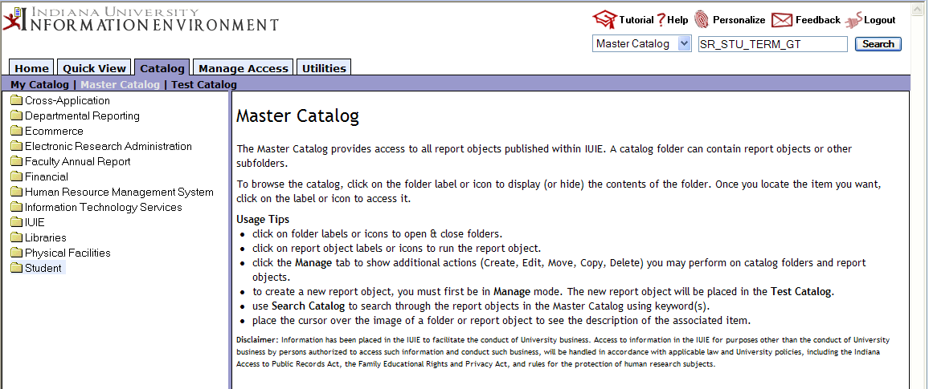
- Scroll down through the search results until you see the name of the table or view that you searched for. Use your mouse to click on the underlined name of the table or view. This will take you to that report object.
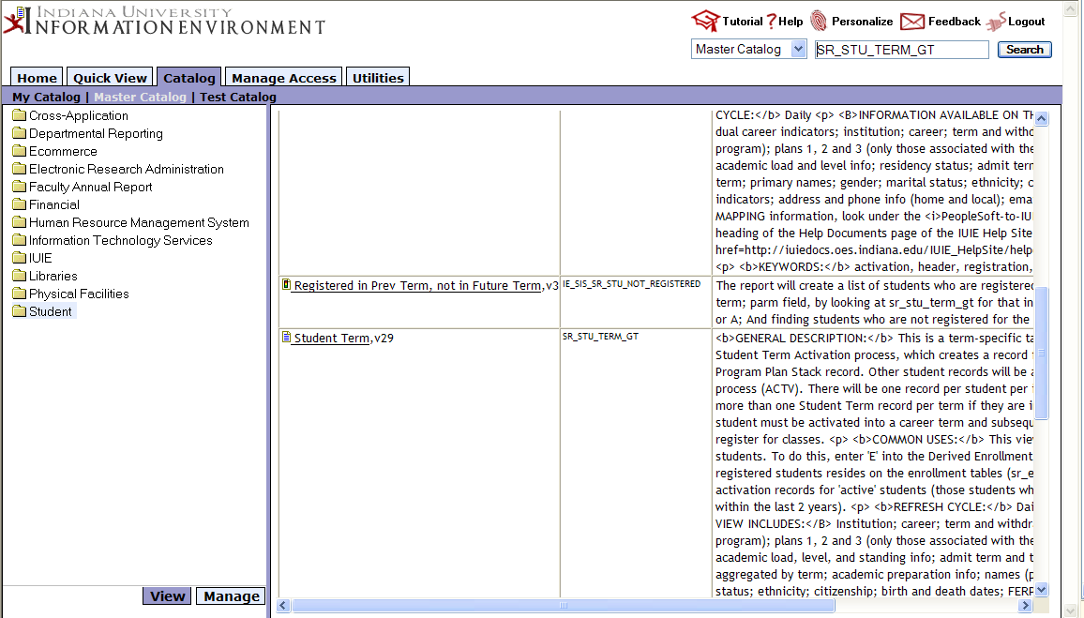
- You may be presented with a secondary screen with different locations for the same table or view. Pick any one of these by clicking on the underlined name of the report object.
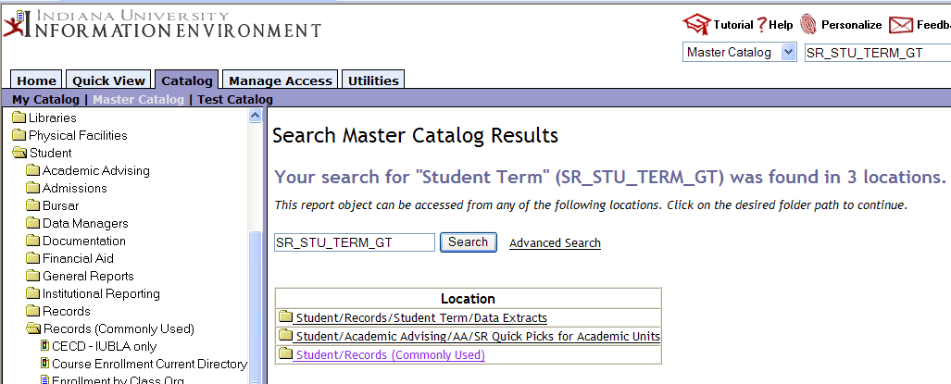
- Once in the report object, scroll down until you find one of the student high school column names.
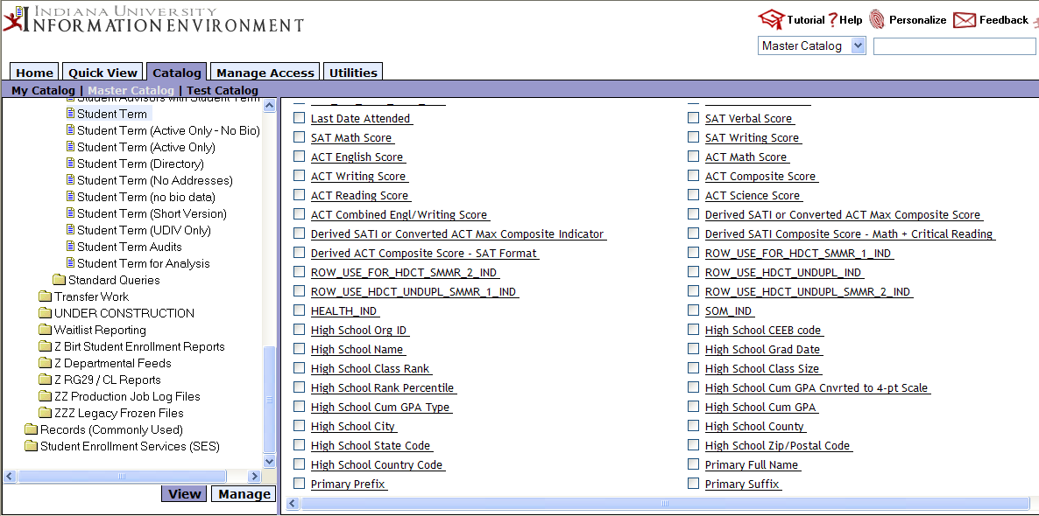
- Click on the underlined column name that you desire. You will then see a display of all tables and views with this column.
